高熵中心材料測試服務設備說明表

儀器名稱 | 中文：電池充放電機台
 | 英文：Battery & Cell Test Equipment (Galvanostatic charge-discharge test / Cyclic Voltametry) |  |  |  |  |  |  |  | 簡稱 | GCD/CV
廠牌 | MACCOR |  |  |  |  |  |  |  | 國別 | 中華民國
型號 | Series 4000 |  |  |  | 放置地點 |  |  |  | 清華實驗室328室
主要附件 | 室溫恆溫箱
重要規格 | Voltage Ranges: 0-5V  Current Ranges: 150 µA, 5 mA, 150 mA, 5 A  Voltage Accuracy: 0.02% of full scale voltage  Current Accuracy: 0.05% of full scale current on all other channels  Time Resolution: 10 mS standard
儀器性能 | Operating Modes: Constant Current, Constant Voltage, Constant Power, Constant Resistance, Voltage Scan (Cyclic Voltametry)
服務項目 | 恆電流充放電、恆電壓充放電、循環伏安法
試片規格 | 圓形鈕扣電池(如CR2032、CR2016等)、軟包電池(Pouch Cell)
收費方式 | 項目 |  |  | 學研單位 |  |  |  | 業界
 | 開機費 |  |  | 不收費 |  |  |  | 不收費
 | 儀器使用費 |  |  | 1,800元/3日 |  |  |  | 2,400元/3日
 | 委託數據分析 |  |  | 750元/件 |  |  |  | 1,000元/件
備註:電化學量測服務，儀器使用費依照量測時間計價。
- 儀器使用基本收費每件2,400元/3日，不足3日以3日計價。
- 量測時間第4日～第30日(含)，每日500元/日；第31日(含)以上則以400元/日收費。
設備照片 | 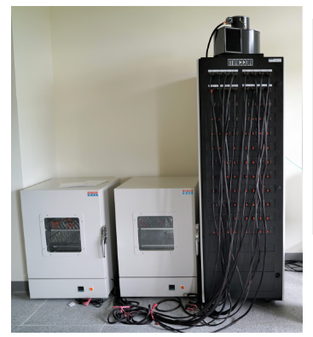
指導教授 | 陳翰儀教授 | TEL | (03)5715131#33849 |  |  | E-MAIL | chenhannyi@gmail.com
管理人員 | 林佳慶 | TEL | (03)5715131#33808 |  |  | E-MAIL | jack30219@gmail.com
 | 劉世福 | TEL | (03)5715131#33808 |  |  | E-MAIL | a2132151518@gmail.com
委測需求 | 請與管理人員接洽及預約

